Homework 3

Array & String

**Example 1 of Multidimensional Array In C**

Write a C program to find sum of two matrix of order 2*2 using multidimensional arrays where, elements of matrix are entered by user.

**#include**<stdio.h>

**int** **main**() {

**float** matrix_1[2][2] = { };

**float** matrix_2[2][2] = { };

**float** SumMatrix[2][2] = { };

**printf**("Enter the elements of 1st matrix\n");

**for** (**int** i = 0; i < 2; i++) {

**for** (**int** j = 0; j < 2; j++) {

**printf**("Enter matrix_1[%d][%d]:", i, j);

**fflush**(stdout);

**scanf**("%f", &matrix_1[i][j]);

}

}

**printf**("\nEnter the elements of 2nd matrix\n");

**for** (**int** i = 0; i < 2; i++) {

**for** (**int** j = 0; j < 2; j++) {

**printf**("Enter matrix_2[%d][%d]:", i, j);

**fflush**(stdout);

**scanf**("%f", &matrix_2[i][j]);

}

}

**int** j = 0;

**for** (**int** i = 0; i < 2; i++) {

**for** (j = 0; j < 2; j++) {

SumMatrix[i][j] = matrix_2[i][j] + matrix_1[i][j];

}

}

**printf**("\nSum of Matrix:\n");

**for** (**int** i = 0; i < 2; i++) {

**for** (j = 0; j < 1; j++) {

**printf**("%0.2f %0.2f\n", SumMatrix[i][j], SumMatrix[i][j + 1]);

}

}

**return** 0;

}

|  |  |  |
| --- | --- | --- |
| matrix_1[0][0] | 2 | 0x61fef4 |
| matrix_1[0][1] | 0.5 | 0x61FEF8 |
| matrix_1[1][0] | -1.1 | 0x61FEFC |
| matrix_1[1][1] | 2 | 0x61FF00 |

|  |  |  |
| --- | --- | --- |
| matrix_2[0][0] | 0.2 | 0x61fee4 |
| matrix_2[0][1] | 0 | 0x61FEE8 |
| matrix_2[1][0] | 0.23 | 0x61FEEC |
| matrix_2[1][1] | 23 | 0x61FEF0 |

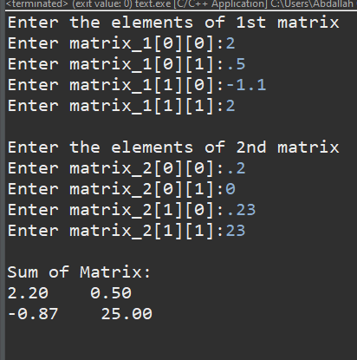

test cases

|  |  |  |
| --- | --- | --- |
| SumMatrix[0][0] | 2.20 | 0x61fed4 |
| SumMatrix[0][1] | 0.50 | 0x61FED8 |
| SumMatrix[1][0] | -0.87 | 0x61FEDC |
| SumMatrix[1][1] | 25.0 | 0x61FEE0 |

**Example 2 C Program to Calculate Average Using Arrays**

This program takes **N** number of elements from user (where, n is specified by user), stores data in an array and calculates the average of those numbers.

**#include**<stdio.h>

**int** **main**() {

**int** N;

test cases

**float** sum=0;

**printf**("Enter the numbers of data:");

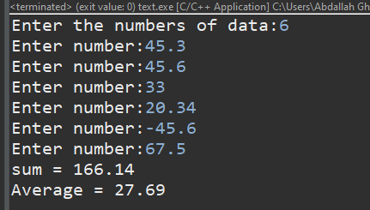 **fflush**(stdout);

**scanf**("%d",&N);

**float** arr[N];

**for**(**int** i=0;i<N;i++){

**printf**("Enter number:");

**fflush**(stdout);

**scanf**("%f",&arr[i]);

sum+=arr[i];

}

**printf**("sum = %0.2f\n",sum);

**printf**("Average = %0.2f",(sum/N));

**return** 0;

}

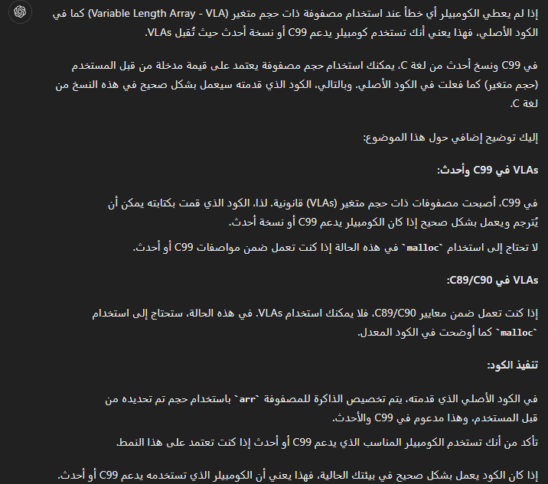

**Example 3 C Program to Find Transpose of a Matrix**

This program asks user to enter a matrix (size of matrix is specified by user) and this program finds the transpose of that matrix and displays it.

**#include** <stdio.h>

**int** **main**() {

**int** rows;

**int** columns;

**printf**("Enter rows and columns of matrix: ");

**fflush**(stdout);

**scanf**("%d %d", &rows, &columns);

**int** matrix[rows][columns];

test cases

**for** (**int** i = 0; i < rows; i++) {

**for** (**int** j = 0; j < columns; j++) {

**printf**("Enter element matrix[%d][%d]: ", i, j);

**fflush**(stdout);

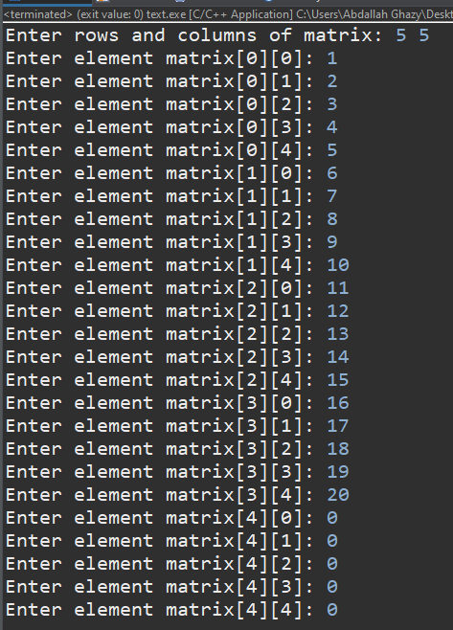 **scanf**("%d", &matrix[i][j]);

}

}

**printf**("\nEntered Matrix:\n");

**for** (**int** i = 0; i < rows; i++) {

**for** (**int** j = 0; j < columns; j++) {

**printf**("%d\t", matrix[i][j]);

}

**printf**("\n");

}

**int** matrix_T[columns][rows];

**for** (**int** i = 0; i < rows; i++) {

**for** (**int** j = 0; j < columns; j++) {

matrix_T[j][i] = matrix[i][j];

}

}

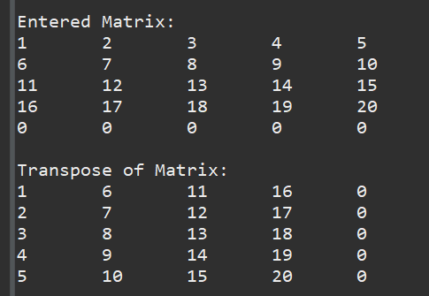

**printf**("\nTranspose of Matrix:\n");

**for** (**int** i = 0; i < columns; i++) {

**for** (**int** j = 0; j < rows; j++) {

**printf**("%d\t", matrix_T[i][j]);

}

**printf**("\n");

}

**return** 0;

}

**Example 4 C Program to Insert an element in an Array**

**#include** <stdio.h>

**int** **main**() {

**int** N;

**int** element;

**int** location;

**printf**("Enter number of elements: ");

**fflush**(stdout);

**scanf**("%d", &N);

**int** arr1[N];

**for** (**int** i = 0; i < N; i++) {

arr1[i] = i + 1;

}

**printf**("Original array: ");

**for** (**int** i = 0; i < N; i++) {

**printf**("%d ", arr1[i]);

}

test cases

**printf**("\n");

**printf**("Enter the element to be inserted: ");

**fflush**(stdout);

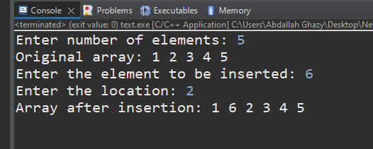 **scanf**("%d", &element);

**printf**("Enter the location: ");

**fflush**(stdout);

**scanf**("%d", &location);

**if** (location < 1 || location > N + 1) {

**printf**("Invalid location!\n");

**return** 1;

}

**int** arr2[N + 1];

**for** (**int** i = 0, j = 0; i < N + 1; i++) {

**if** (i == location - 1) {

arr2[i] = element;

} **else** {

arr2[i] = arr1[j++];

}

}

**printf**("Array after insertion: ");

**for** (**int** i = 0; i < N + 1; i++) {

**printf**("%d ", arr2[i]);

}

**printf**("\n");

**return** 0;

}

**Example 5 C Program to Search an element in Array**

**#include** <stdio.h>

**int** **main**() {

**int** NElements;

**int** SElements;

**int** flag = 0;

**int** location = 0;

**printf**("Enter no of elements :");

**fflush**(stdout);

**scanf**("%d", &NElements);

**int** arr[NElements];

**for** (**int** i = 0, j = 1; i < NElements; i++, j++) {

arr[i] = (j * 10) + j;

**printf**("%d\t", arr[i]);

}

**printf**("\nEnter the elements to be searched :");

**fflush**(stdout);

**scanf**("%d", &SElements);

**for** (**int** i = 0; i < NElements; i++) {

**if** (SElements == arr[i]) {

flag = 1;

location = i + 1;

**break**;

}

}

**if** (flag == 1) {

**printf**("Number found at the location = %d", location);

} **else** {

**printf**("\nNumber %d is not available", SElements);

}

**return** 0;

}

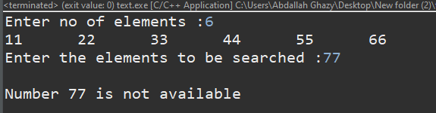

test cases

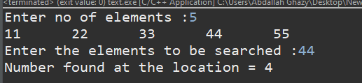

**Example 6 C Program to Find the Frequency of Characters in a String**

This program asks user to enter a string and a character and this program checks how many times that character is repeated in the string entered by user.

**#include** <stdio.h>

**int** **main**() {

**char** string[100];

**char** character;

**char** counter = 0;

**printf**("Enter a string: ");

**fflush**(stdout);

**gets**(string);

**printf**("Enter a character to find frequency: ");

**fflush**(stdout);

**scanf**("%c", &character);

**for** (**int** i = 0; i < **sizeof**(string); i++) {

**if** (character == string[i]) {

counter++;

}

}

**if** (counter) {

**printf**("Frequency of %c = %d", character, counter);

} **else** {

**printf**("The character is missing.");

}

**return** 0;

}

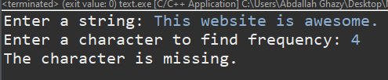

test cases

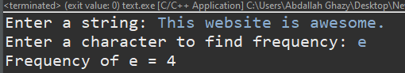

**Example 7 C Program to Find the Length of a String**

You can use standard library function strlen() to find the length of a string but, this program computes the length of a string manually without using strlen() function.

**#include** <stdio.h>

**int** **main**() {

**char** string[100];

**char** counter = 0;

**printf**("Enter a string: ");

**fflush**(stdout);

**gets**(string);

**for** (**int** i = 0; string[i] != 0; i++) {

counter++;

}

**if** (counter) {

**printf**("Length of string: %d", counter);

} **else** {

**printf**("Please enter the text");

}

**return** 0;

}

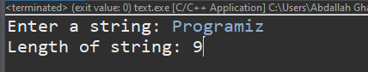

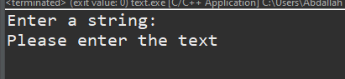

test cases

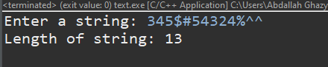

**EX3: C Program to Reverse String Without Using Library Function**

You can only use library function strlen(), To find the length of the string

**#include** <stdio.h>

**int** **main**() {

**char** string[100];

**char** counter = 0;

**printf**("Enter a string: ");

**fflush**(stdout);

**gets**(string);

**for** (**int** i = 0; string[i] != 0; i++) {

counter++;

}

**char** Rstring[counter];

**for** (**int** i = counter - 1, j = 0; i >= 0; i--, j++) {

Rstring[j] = string[i];

}

Rstring[counter] = 0;

**if** (counter) {

**printf**("Reverse string is : %s", Rstring);

} **else** {

**printf**("Please enter the text");

}

**return** 0;

}

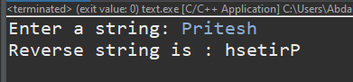

test cases

